# Screenshots of System

# Login Window

# 

# Register Window

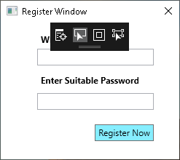

# Main Window

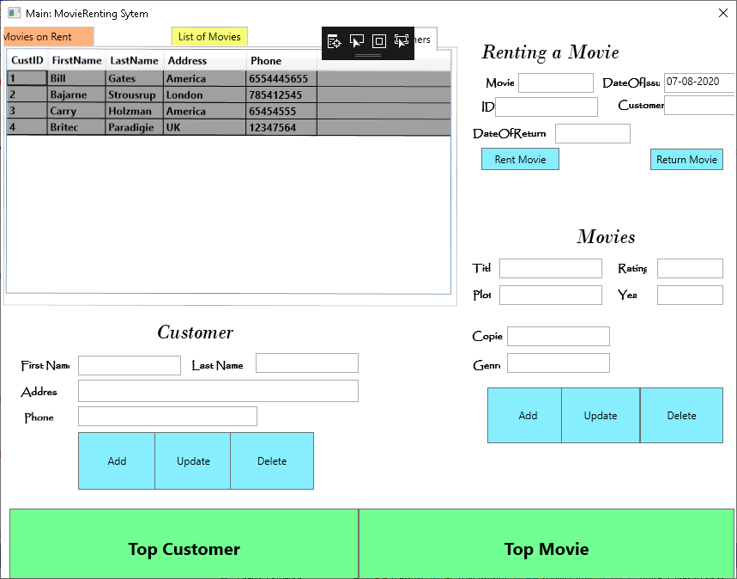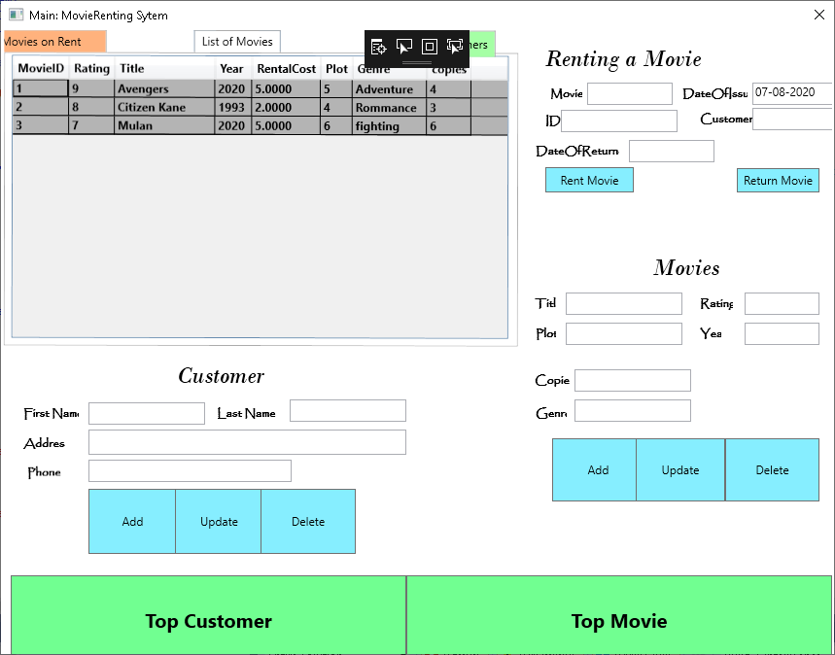

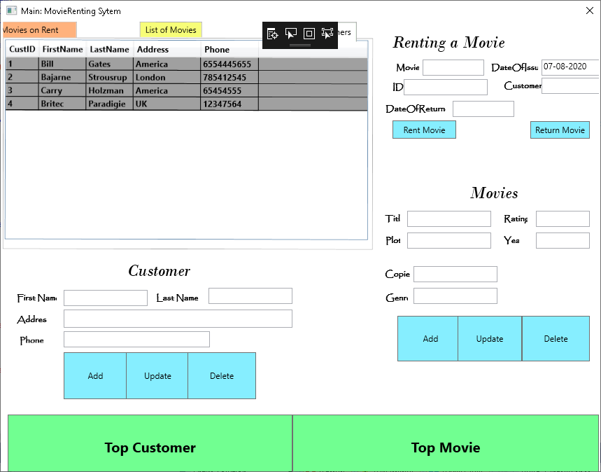

# Test Cases:

**Test Case:** ADD MOVIES

1: Add a movie and show in data grid

2: Do not allow user to add same movie

3: Do not add blank movie

Status: **Success**

**Test Case:** ADD CUSTOMER

1: Add a CUSTOMER and show in data grid

2: Do not allow user to add Special chars

3: Do not add blank Customer

Status: **Success**

**Test Case:** Update MOVIES & CUSTOMER

1: should able to change details of movie and customer

Status: **Success**

**Test Case:** DELETE A MOVIE & CUSTOMER

1: Should not delete a movie which is rented

2: Should not delete a customer who rented the movie

Status: **Success**

**Test Case:** GIVE A MOVIE ON RENT

1: should able to add movie on list of rented movies and date of issue should be current date.

2: movie which is already rented should not be issued again

3: cannot issue more than 2 copies to same customer

4: should give error on ‘0’ copies

Status: **Success**

**Test Case:** RETURN A MOVIE FROM CUSTOMER

1: change record accordingly in rented movie table after returning a movie

2: should not return a movie which is not rented out

3: Should also update data of return accordingly

Status: **Success**